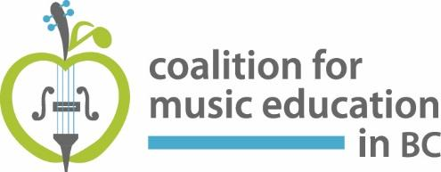
February 12, 2019

Dear Parents, Students, and Supporters of Music Education,

Recently, the Ministry of Education released a report titled “Improving Equity and Accountability- Report of the Funding Model Review Panel 2018.” This report is a product of the government’s review of K-12 funding across BC. There is a recommendation in the report that if implemented, will cause the elimination of many secondary school music programs throughout the province.
Recommendation 9 reads as follows:
The Ministry should base funding allocations for school-age educational programming on the number of students, rather than on the number of courses being taken. The Ministry should phase out the current course-based funding model by the 2020/21 school year.

Funding for schools is currently course-based, meaning that students have the opportunity to enroll in courses of their choice, beyond 8 blocks. If a per-student funding model is implemented, students will lose the opportunity to take more than 8 blocks, and schools will lose funding for teachers to teach these courses, as most of them operate off timetable.

As outlined in the letter that follows, the current course-based funding model offers exceptional flexibility and richness in Fine Arts programming that is aligned with the values of the new BC Curriculum.

Your support and voice are desperately needed to prevent the implementation of a funding model that will decimate our province’s treasured music programs. Please consider adding the required information into the attached letter and sending it to your MLA. Additionally, please share your concerns and your letter with your school’s Parent Advisory Council (PAC) and your district’s council (DPAC).

If sharing on social media, please use the following hashtags:
#PerCourseFunding
#bced
#bcpoli

Sincerely,
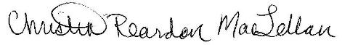

Christin Reardon MacLellan
President, Coalition for Music Education in BC
president@cmebc.org; www.cmebc.org

February 9, 2019

The Honourable (First Name)(Last name)
MLA (riding)
(Address)

Re: Improving Equity and Accountability

Dear (Salutation)(Last name),

Recently, I was made aware that there is a document entitled “Improving Equity and Accountability - Report of the Funding Model Review Panel 2018”. This document outlines recommendations supporting the per-student funding model rather than the current course-by-course funding model. If implemented, the majority of our music, musical theatre, dance, drama, leadership, enrichment, distributed learning, etc., programs could be taken out of our schools. Having a per-student funding model will impact both students and staff. It will limit students’ ability to participate in courses that are offered outside of the timetable and will reduce a teacher’s full-time equivalent (FTE) in their trained subject area.

The current course-by-course funding model has allowed the creation of enriched learning opportunities for performing arts programs, including multi-grade senior level classes that are offered outside of the timetable (which allows for flexibility for students with heavy academic schedules), cross-enrolment performance classes between schools in a district, offering of new courses where students can explore and/or specialize in at all levels allowing flexibility, and enrichment classes including arts, academics, trades/tech, languages, athletics, and leadership. The proposed per-student funding model would cancel many of these courses, causing a significant amount of lost opportunities for our students.

I personally do not want to see any of these vital programs reduced and I strongly believe that changing the funding model will do this. It will affect thousands of jobs, will affect students’ abilities to complete graduation requirements, and will change the course of education for decades to come. I urge you to defeat these recommendations and to keep the current course-by-course funding model.

I look forward to your response,

Sincerely,

(Your name), (City/town)

