 

***{Fundraiser Name}***

***Christmas 2019***

***Fundraiser***

L) 6” Mixed Christmas Planter – $20.00

M) 8” Mixed Christmas Planter – $25.00

N) 10” Mixed Christmas Planter – $30.00

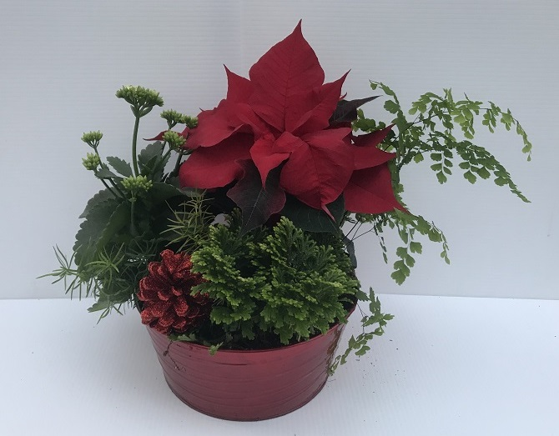

O) 13” Mixed Christmas Planter – $35.00

P) 4” Christmas cactus with pot cover – $6.00

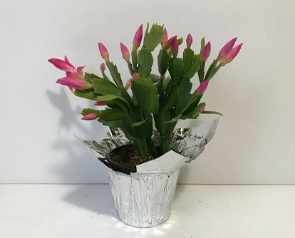

Q) 4” Frosty Fern with pot cover – $6.00

R) 4” Kalanchoe red with pot cover – $6.00

S) 4” Kalanchoe white with pot cover – $6.00

T) 4” Norfolk Pine with pot cover – $12.50

U) 8” Norfolk Pine with plastic cover – $35.00

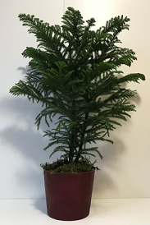

A) 4” Poinsettia Red with pot cover – $6.00

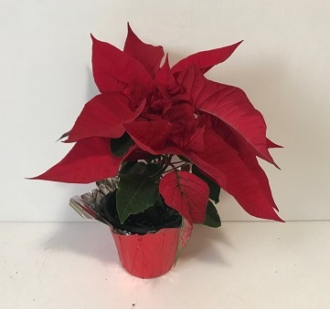  
B) 4” Poinsettia White with pot cover – $6.00

C) 4” Poinsettia Marble with pot cover – $6.00

D) 4” Poinsettia Pink with pot cover – $6.00

E) 6.5” Poinsettia Red with Deco cover – $15.00

F) 6.5” Poinsettia White with Deco cover – $15.00

G) 6.5” Poinsettia Marble with Deco cover – $15.00

H) 6.5” Poinsettia Pink with Deco cover – $15.00

I) 10” Poinsettia Red with pot cover – $30.00

J) 10” Poinsettia Tri Colour with pot cover – $30.00

K) 10” Poinsettia Red with metal cover – $35.00



